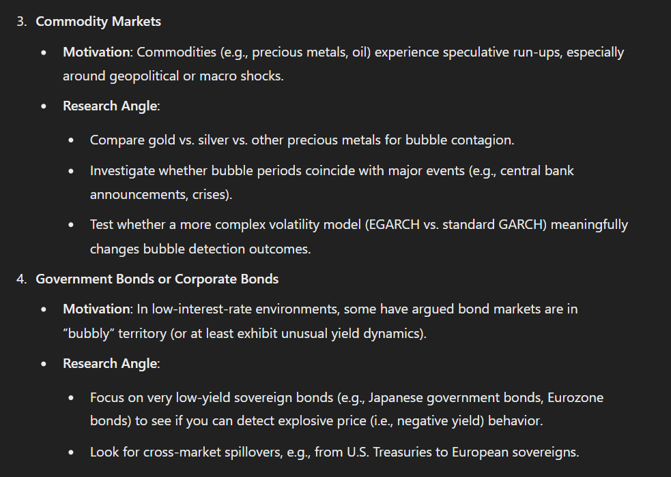

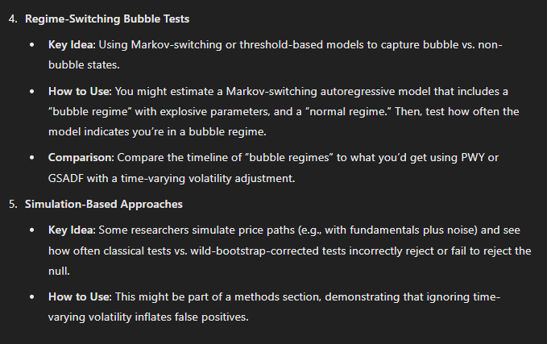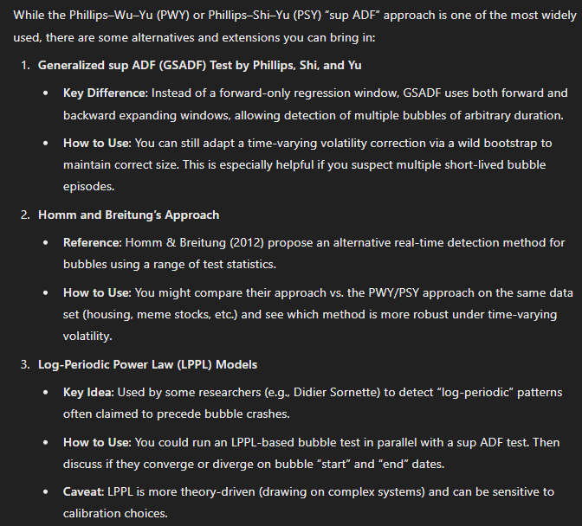

**1. Commodity Markets**

**Why Commodities?**

* **High Volatility**: Commodities such as crude oil, gold, silver, and industrial metals can exhibit rapid price movements in response to geopolitical tensions, supply shocks (e.g., OPEC decisions, mining strikes), or macroeconomic events (e.g., Federal Reserve rate announcements).
* **Speculative Run‐Ups**: Commodity spikes often occur when investors seek “safe havens” (e.g., gold), or jump into markets based on short-term supply/demand imbalances (e.g., oil).

**Possible Angles**

1. **Compare Gold vs. Silver vs. Other Precious Metals**
   * **Motivation**: These metals sometimes move in tandem (e.g., both can be viewed as hedges), but it’s not uncommon to see silver exhibit more dramatic volatility than gold.
   * **Test**: Apply a bubble detection procedure (e.g., Phillips–Shi–Yu’s GSADF) and incorporate Hafner’s time‐varying volatility correction.
   * **Research Questions**:
     + Do these metals display explosive price behavior at the same time (bubble “contagion”)?
     + Does gold lead silver, or vice versa, in bubble formation?
2. **Event‐Related Bubbles**
   * **Motivation**: Commodity price surges may coincide with major events—wars, natural disasters, crises.
   * **Approach**:
     + Identify a time range (e.g., 15–20 years of daily data).
     + Examine known events (e.g., 2008 financial crisis, 2020 COVID shock) for bubble periods.
   * **Method**: The forward or generalized sup ADF test, correcting for time‐varying volatility, then see if the “bubble windows” line up with these external shocks.
3. **Complex Volatility Models**
   * **Motivation**: Commodities often show volatility clustering, regime shifts, and “fat‐tail” distributions. Using EGARCH or FIGARCH (fractionally integrated GARCH) may better capture long memory in volatility.
   * **Practical Step**:
     + Fit an EGARCH or FIGARCH model to the daily returns.
     + Re‐run your bubble tests using a wild bootstrap for correct p‐values under the assumption of nonstationary volatility.

**Potential Data Sources**

* **Gold, Silver, Platinum, Palladium**: Bloomberg, Thomson Reuters, ICE data, or free historical data from sites like Investing.com or Quandl.
* **Oil (WTI or Brent), Gas**: EIA (U.S. Energy Information Administration) or private data providers.

**Challenges and Tips**

* Commodity time series can be heavily influenced by seasonality (especially agricultural commodities). Consider controlling for known seasonal effects if you look at something like corn or wheat.
* The question of “fundamental value” is tricky. For precious metals, some might argue the fundamental value is driven by industrial use plus some store‐of‐value demand; for oil, fundamentals relate to global demand and OPEC decisions. The bubble test approach (as in Hafner’s paper) typically side‐steps the need for a clear fundamental by focusing on whether *prices themselves* show explosiveness.

**2. Government Bonds or Corporate Bonds**

**Why Bonds?**

* **Current Environment**: In the past decade, interest rates have been historically low in many regions; some analysts have referred to a “bond bubble,” as bond prices rose and yields dropped.
* **Negative Yields**: Several countries (e.g., Japan, Germany) have experienced negative yields, which may be seen as unusual or “explosive” pricing in the sense that investors pay to hold debt.

**Possible Angles**

1. **Very Low‐Yield Sovereign Bonds**
   * **Motivation**: Look at Japanese government bonds (JGBs), German bunds, Swiss bonds, or other markets that have gone negative/ultra-low.
   * **Research Question**:
     + Do these bond price increases display bubble characteristics?
     + Are there repeated short‐lived periods of explosiveness (mini‐bubbles) vs. one big prolonged bubble?
   * **Methodology**:
     + Gather daily or weekly yield data (transform to prices if necessary) and apply the bubble tests.
     + Because yields are small, returns might be less volatile on the surface, so the time‐varying volatility correction is still important—volatility might be lower overall but could shift around specific announcements (e.g., central bank policy meetings).
2. **Cross‐Market Spillovers**
   * **Motivation**: Yields in major markets (U.S. Treasuries, German bunds) often move in sync, but do bubble signals in one region appear first and then show up in another?
   * **Approach**:
     + Collect bond yield data from multiple sovereign issuers.
     + Run your bubble detection in each market individually.
     + Look for overlapping bubble intervals or examine if “bubble episodes” in the U.S. lead bubble episodes in Europe.
   * **Extensions**: Could also include corporate bonds—particularly high‐yield (“junk”) bonds—to see if they experience a separate or stronger bubble phenomenon than sovereign debt.
3. **Liquidity and Market Microstructure**
   * **Motivation**: Some bond markets are more liquid than others; large central bank asset purchases (quantitative easing) affect yields in ways that may appear “excessive.”
   * **Research Question**:
     + Do central bank interventions create bubble‐like price patterns in long‐dated bonds?
     + Does liquidity dryness in certain corporate bond segments lead to episodic price spikes (bubbles)?

**Potential Data Sources**

* **Bloomberg Terminal, Thomson Reuters Eikon**: Provide historical bond yields/prices.
* **Central Bank Databases**: For example, the Federal Reserve Bank (FRED) site for U.S. Treasury yields, ECB for Euro‐area yields, Bank of Japan for JGBs.
* **Datastream**: Also widely used in academic research for bond series.

**Challenges and Tips**

* If you are using yields, you need to convert yields to “price-like” series to apply many bubble tests directly (most tests assume you have a price series). One approach is to treat the yield *minus* a time‐varying “fundamental yield” as an equivalent measure; another is to invert yield into a bond “price proxy” for a zero-coupon or standard coupon bond.
* Bonds can have strong macro linkages, so you may want to control for major monetary policy announcements (Fed, ECB, BoJ, etc.) to see if bubble signals spike around those times.

**3. Practical Steps for Both Markets**

1. **Gather Data & Clean It**
   * Make sure you have consistent frequency (daily, weekly, monthly).
   * If you have multiple commodities or multiple bonds, align the sample period.
2. **Check for Nonstationary Volatility**
   * Fit a GARCH‐type model or conduct simpler diagnostics (e.g., rolling variance) to confirm that volatility evolves over time and is not stationary.
3. **Choose Your Bubble Test**
   * The Phillips–Shi–Yu (PSY) or generalized sup ADF (GSADF) approach is common.
   * Consider your preference for forward vs. backward expansions and whether you expect multiple short bubbles or a single long bubble.
4. **Apply a Wild Bootstrap or Similar Correction**
   * This ensures your p‐values aren’t distorted by time‐varying volatility.
5. **Interpret and Possibly Date‐Stamp**
   * If you reject the null of “no bubble,” try to estimate the start and end points of bubble episodes.
   * Compare across multiple commodities (or multiple bond markets) for possible contagion or lead–lag patterns.
6. **Relate to Real‐World Events**
   * Once you’ve identified bubble intervals, check if they coincide with known macro/market events (rate cuts, crises, supply disruptions).

**Final Notes**

* Both commodities and bonds lend themselves to the same core methodological approach (recursive bubble tests with corrections for volatility).
* The main difference is in data characteristics—commodities are often more volatile, while bond yields can appear calmer but might exhibit structural breaks or regime shifts.
* From an academic standpoint, either market could be compelling, particularly if you address a current topic (e.g., negative yield phenomena, post‐pandemic commodity surges).

Overall, whether you pick commodities or bonds, you’ll be taking Hafner’s insight— “Testing for Bubbles with Time‐Varying Volatility”—and applying it to a fresh domain. This can yield an interesting thesis on whether standard bubble tests still hold up once you adjust for evolving volatility patterns, and on whether there are meaningful bubble “contagion” dynamics across different assets.